Lesson plan 5: Representing text

About the lesson
It is amazing to think that everything our digital devices do for us and everything a computer produces is broken down into just two digits, 0 and 1, so it can be processed. This lesson introduces students to data representation. The students will learn how letters of the alphabet are represented in computer code, how the ASCII system has standardised the way characters are represented and how to convert ASCII text to binary and vice versa.
There is an extension activity, which more-able students may find time to attempt, that introduces a third numbering system used for creating computer code: hexadecimal.
Learning objectives
By the end of this lesson, students will:
- understand how the ASCII system has standardised the way characters are represented
- be able to convert ASCII text into binary strings and vice versa.
National curriculum
The following subject content from the KS3 National Curriculum is included in this lesson:
- Understand simple Boolean logic (for example, AND, OR and NOT) and some of its uses in circuits and programming; understand how numbers can be represented in binary, and be able to carry out simple operations on binary numbers (for example, binary addition, and conversion between binary and decimal)
- Understand how instructions are stored and executed within a computer system; understand how data of various types (including text, sounds and pictures) can be represented and manipulated digitally, in the form of binary digits
Links
Students who have completed the Computing components module, Lesson 3 will have encountered the use of binary to represent characters. Binary is a fundamental concept in computing that will prove useful for any further study of the topic. Students who have completed the Introduction to spreadsheets and Advanced spreadsheets modules will have encountered all the necessary features required to complete the tasks. Students who have completed the Internet safety, cyber security and encryption module, Lesson 5 will also have encountered the necessary skills to complete the tasks in this lesson
Key terminology
ASCII, bit, byte, Unicode
Teaching and learning activities
Share the objectives for the lesson with students (Slide 2 of Lesson 5 presentation).
Starter
Recap the binary system (Slide 3 and page 132).
Ask: How much of the content you input into, or view on, your digital devices is in the form of numbers?
The answer will be very little; mostly students will input or view text, images, audio and video.
Ask: How can a computer handle text, images, audio and video when, as we know from previous lessons, all the processing that takes place inside a computer is done using binary code, using 1s and 0s?
The text, images, audio and video are converted to binary code so that they can be processed by the computer. Emphasise how amazing it is that everything our digital devices do for us and everything a computer produces is broken down into just two digits, 0 and 1, so that it can be processed.
Explain how characters are processed (Slide 4 and page 132).
Ask: We call the characters on the keyboard a 'character set'. When people think of a character set, they usually imagine the 26 letters of the alphabet, but the keyboard needs to generate more than 26 letters. Why?
The keyboard is used to enter both upper- and lower-case letters.
Ask: What other characters do you enter using a keyboard?
Non-letter characters, such as > $ ' ] / : and .
Ask: Would the keyboard you normally use be useful to someone typing in Chinese or Arabic?
No. Chinese and Arabic use completely different character sets from English.
Explain that standardisation is essential because we cannot assign the same denary number and binary string to two different characters if applications are to work on a range of different devices and on a global scale.
Part 1
Introduce the American Standard Character set for Information Interchange (ASCII) (Slide 5 and page 132).
Ask: What is the ASCII denary value of a capital A? Answer: 65
Ask: What is the ASCII denary value of a lower-case a? Answer: 97
Explain how a character is converted to binary and introduce students to the terms 'bit' and 'byte' (Slides 6–7 and page 132).
Ask students to complete Activity 5.1: ASCII converter (Excel workbook 5, sheet 1/Excel workbook 5.1; Google Sheets workbook 5, sheet 1/Google sheets workbook 5.1, slide 8).
- Students will need the cards they made for Activity 2.2 to complete this activity.
- The cells in the spreadsheet turn green when students have entered the correct answers.

Answers
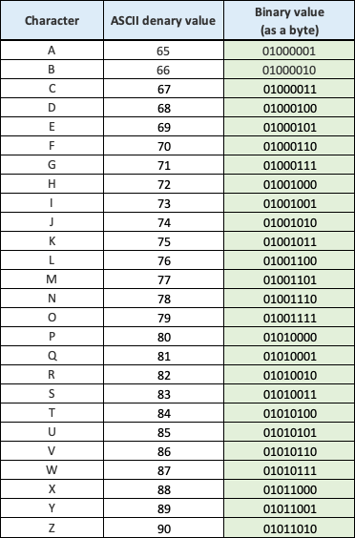
Part 2
Ask students to complete Activity 5.2: Processing a character like a computer (Part 1) (Excel workbook 5, sheet 2/Excel workbook 5.2; Google Sheets workbook 5, sheet 2/Google sheets workbook 5.2, slide 9)
Activity 5.3: Processing a character like a computer (Part 2) (Excel workbook 5, sheet 3/Excel workbook 5.3; Google Sheets workbook 5, sheet 3/Google sheets workbook 5.3, slide 10)
- Students will need to use the ASCII converter they created for Activity 5.1 for this activity.
- You may want to draw a parallel between the conversion a computer does to process characters and encryption and decryption if students have already completed the Internet safety, cyber security and encryption module.
- Students will need to work in pairs, swapping computers with a partner to complete Activity 5.3.
Ask students who finish early to complete Activity 5.4: Hexadecimal (Worksheet 5.4, slide 11).
Common misconceptions
Students often find it difficult to appreciate how the letters A–F represent the values 10–15. Students often do not appreciate that hexadecimal is used as a shorthand for programmers. It is important to make sure students are clear that computers do not use hexadecimal but work in binary.
Answers
- 54 68 69 73 20 63 6F 64 65 20 68 61 73 20 62 65 65 6E 20 63 6F 6E 76 65 72 74 65 64
- Data is always stored and processed in binary, but entering data using hexadecimal numbers is much quicker for programmers and they are far less likely to make a mistake.
Plenary
Ask: How many different ways do you think 8 bits can be arranged into a byte?
Give students the opportunity to make a few guesses, and then tell them that there are only 256 different ways 8 bits can be arranged into a byte.
Ask: Do you think 256 characters can represent all the characters in all the languages in the world? After a brief discussion, reveal the answer (Slide 11 and page 133).
Homework
Ask students to complete Quiz 5 (slide 13).
Stretch activities
Some students may find these activities straightforward and complete the tasks very quickly. These students should be encouraged to complete Activity 5.4.

Support activities
Some students may find the task more challenging and will struggle to complete Activity 5.1 so it will be useful to have completed copies of this available.
Activity 5.3 is a paired activity, but some students may benefit from being paired with another student with similar experience and skills to complete all activities so that they can work together to complete the tasks. Grouping students in this way should ensure that they both gain something from the process, although it means that any assessment results data will be less reliable.

